Setup Guide for Twitter Project

## Step 1: Configure Chrome User Data Directory

1. **Log in to Twitter** using your default Chrome account.
2. **Locate Your Chrome User Data Directory**:
   * Open Chrome and type chrome://version/ in the address bar.

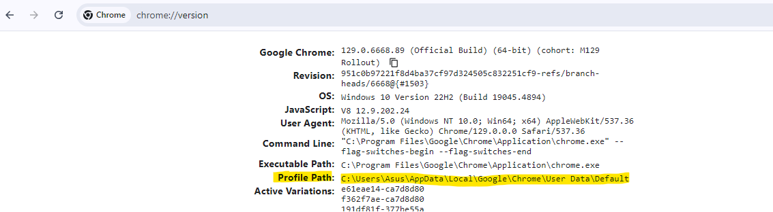

* + Look for the **Profile Path**. It will typically be in the following format:

C:\Users\<YourUsername>\AppData\Local\Google\Chrome\User Data

* + Replace <YourUsername> with your actual Windows username. Update the path in your Config.py accordingly:

CHROME_USER_DATA_DIR = r"C:\Users\Asus\AppData\Local\Google\Chrome\User Data"

## Step 2: Download Models and Vectorizer

1. **Download the Required Models and Vectorizer**:
   * Access the Google Drive link: [Download Models and Vectorizer](https://drive.google.com/drive/folders/1m9bBdGJnXUH2bqxUGpHMbXOOz4KJzSmE?usp=sharing).
   * Download all the files from the folder.
2. **Place Files in the Correct Directory**:
   * Move the downloaded models and vectorizer files into the following directory of your project: src\models

## Step 3: Set Up MongoDB

1. **Install MongoDB**:
   * If you haven't already, install MongoDB on your system. Follow the installation instructions for your operating system from the [MongoDB Documentation](https://docs.mongodb.com/manual/installation/).
2. **Create Database and Collections**:
   * Open the MongoDB shell or use a GUI tool like MongoDB Compass.
   * Create a database named **"Twitter"**:
3. Create two collections within the database:
   * db.createCollection("Predictions")
   * db.createCollection("Posts")

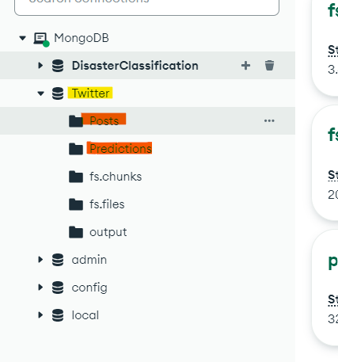

## Step 4: Set Up the Virtual Environment

1. **Open Visual Studio Code**:
   * Launch Visual Studio Code and open the **DisasterClassification** folder.
2. **Set Up a Virtual Environment**:
   * Open the terminal in VS Code (View > Terminal) and run the following command to create a virtual environment: python -m venv venv
3. **Install the required packages using the requirements.txt file:**
   * pip install -r requirements.txt

## Step 5: Run the Application

1. **Navigate to app.py**:
   * In the VS Code file explorer, locate and open the app.py file.
2. **Execute the Application**:
   * Run the following command in the terminal: python app.py
   * Check the console output to see where the website is deployed locally. You should see something like: Running on <http://127.0.0.1:5000/>

NOTE: OPEN THE LINK IN SOME OTHER BROWSER APART FROM CHROME. BECAUSE CHROME WILL BE USED FOR SCARPING

